Falcon Estates HOA Newsletter

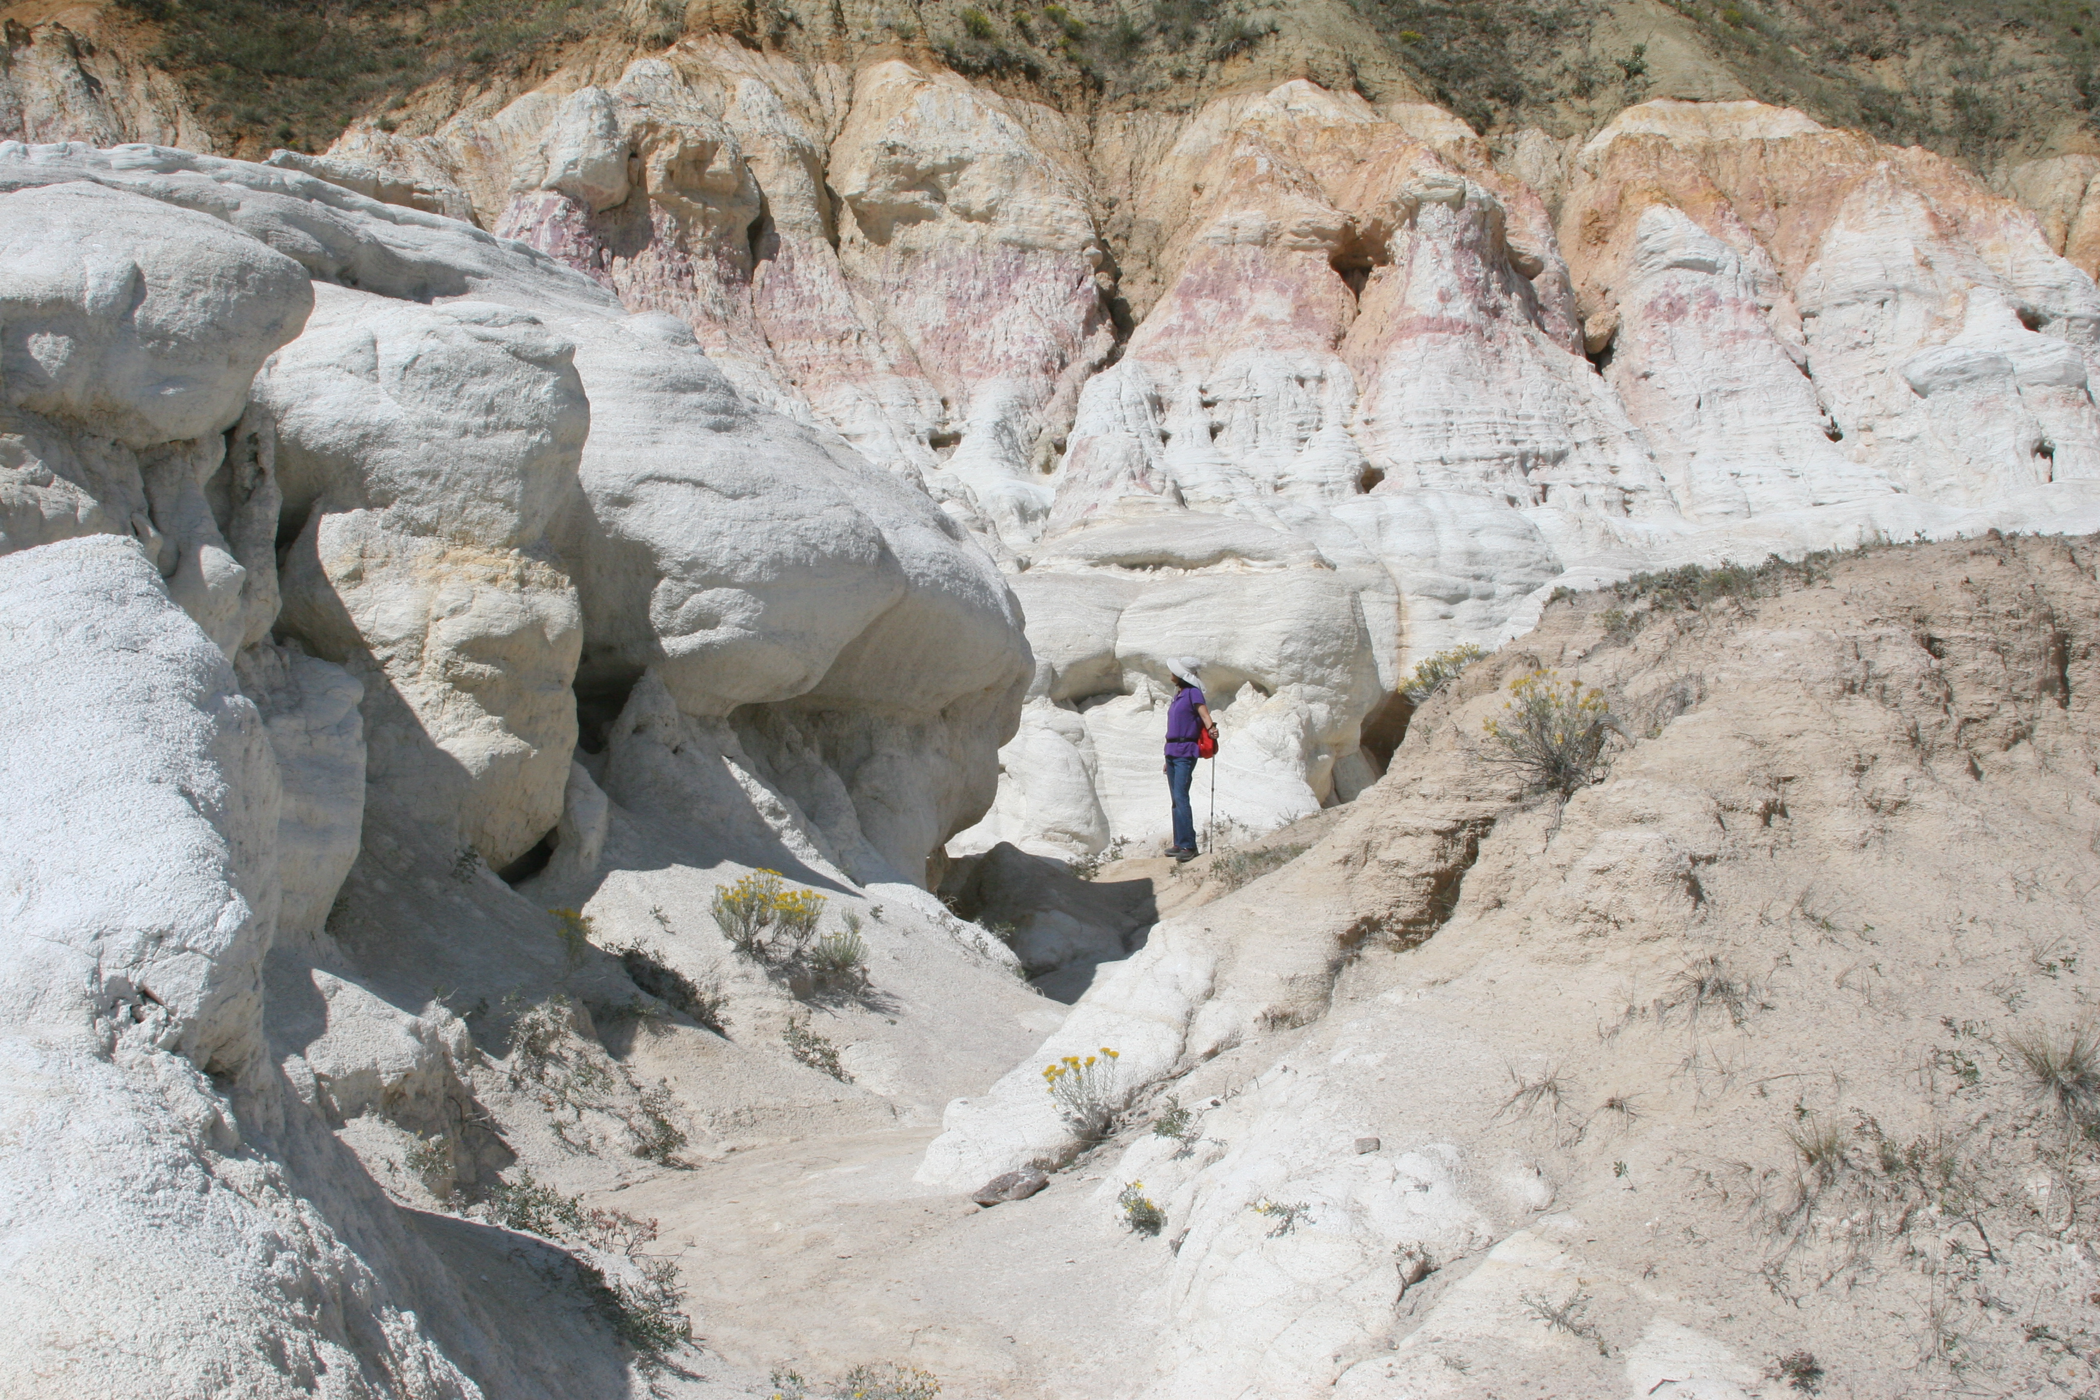

Neighborhood News

**FEHOA Board Meeting: July 23, 2024 @ 6:00 pm** @ 21C Library Room B6

**General Meeting:** Tuesday **July 30 @ 5:30 pm** @ Venue Room

Neighborhood Upcoming Events

Chipping Program the week starting **July 8, 2024, and September 30, 2024**.

FEHOA Cleanup will be July 20 & 21. The second cleanup: October 12 & 13.

FEHOA Board Meeting Tuesday August 27 at 6:00 pm @ 21C Library Room B6

Christmas Lights Contest – December 14 & 15, 2024

General Meeting January 28, 2025

Neighborhood Dues

HOA Dues are due in January of each year. HOA dues for 2024 are $40.

New Falcon Estates HOA email & Webpage

We have a new email address [hoafalconestates@gmail.com](mailto:hoafalconestates@gmail.com). Please use this new email address to contact us and document conversations with the HOA Board. We also have a new webpage <https://hoafalconestates.com/>. Please visit us.

FEHOA Cleanup will be July 20 & 21 9AM to 4PM

We will schedule 2 dumpsters. Locations will be at West-1114 Venhorst and East-1911 Copley. Only HOAFE paid members will be allowed to use the dumpsters. You will be able to pay your 2024 dues at the dumpsters. Exact change or checks, please. HOAFE board members will monitor the dumpsters from 9 AM until 4 PM and be locked afterward. Additional volunteers are requested.

Neighborhood Safety Awareness

**THEFTS:** If you see something suspicious, report to CSPD non-emergency number (719.444.7200).

**HOMELESS:** There have been frequent homeless people camping out on our private properties. Please stay vigilant and review your property & vehicles often to secure it as much as possible. If your encounter these individuals, please always remain safe and contact CSPD non-emergency number (719.444.7200) to have them address the issue.

**WILDLIFE:** Please remain aware of our local wildlife as they can appear at almost any time. Please be SAFE and BE AWARE for yourselves, children, and pets! You are responsible for dead animals on your property. A large animal removal is expensive. Ensure dead animals remain on city property and call (719.444.7891).

Neighborhood Cleanliness

**Lawn Care:**  Ground cover, grasses and weeds, should not exceed 24 inches. You are responsible for easements and ditches on or adjacent to your property. Colorado Springs [landscape_code](https://coloradosprings.gov/system/files/2023-06/cos_landscape_code_and_policy_manual_6_5_23.pdf).

**PETS:** Dogs must be on a leash, if not on your property. Thank you to everyone who cleans up after your dog.

Colorado Springs Regulations

[8.7: DOGS; DOMESTIC ANIMALS](https://coloradosprings.gov/planning/page/dab-401-city-regulations-animals)::  
[6.7.107: DUTY TO RESTRAIN ANIMALS](https://codelibrary.amlegal.com/codes/coloradospringsco/latest/coloradosprings_co/0-0-0-7038)

1. It shall be unlawful for an owner or keeper to allow any dog, cat or hoofed animal to trespass on another's property or to run at large.

HOAFE Free Libraries

Remember Falcon Estates has free libraries at 7231 Milner on the West side and 7100 Ross Drive on the East side. Take one/add one.

FEHOA Board Meeting Summary (25 June 2024)

59 members of Falcon Estates have paid their voluntary dues for 2024, to date.

Looking for volunteers to participate in neighborhood watch. Contact Dawn Neeley.

The recovery house on the corner of Milner and Collins is moving forward with upgrades to septic tank, electrical and fire sprinklers per city requirements.

The Traffic Calming Meeting on June 20th (with 65 people in attendance) included HOAFE, Briargate Chapel Hills, & Columbine Estates and generated a good review of the traffic issues on how to reduce residential traffic speeds on the east side. The closure discussion for Collins has 75% percent opposition and will not be considered. Traffic speed options included speed tables, lane narrowing (painting), mini roundabouts, and chicanes.

The HOA secretary position has been vacated. Bonnie Bagley had volunteered to fill the HOA secretary position until a permanent secretary can be elected.

The board will request a presentation by CSFD on fire wise mitigation at the July General meeting.

Still looking into a community event this summer, such as, ice cream social, hamburger/hotdog BBQ. Looking for suggestions on activities for kids during such an event.

Looking for suggestions during the July General meeting for a "Good Neighbor Award" to be presented at the January 2025 General Meeting.

Neighborhood Board & Volunteers

**VOTING MEMBERS:** Phone Email

Scott Conner Chair 954.668.7107 JScott@ArcUrb.com Andrew Dalby Vice-Chair

Bonnie Bagley Secretary 719.593.0205 Bon1Bon@comcast.net

Tim Fishel Treasurer/Newsletter

Dana Olson Board Member 719.650.0216 DanaOlson49@yahoo.com

**VOLUNTEERS:**

Dawn Neeley ACC Chair 803.464.0831 Dawn.Neeley@mac.com

Stacie Conner Events 954.665.7924 ConnerHome@hotmail.com

## VOLUNTEERING

Members of the board really would like any assistance you can provide. Let us know whatever you may be willing to help out to strengthen our community.

## Contacting the HOA boarD

Members of the board would really like to hear from all our neighbors. We ask that you reach out to us through the HOA email when you have formal HOA business. This helps us keep track of notices and helps us in our goal to be paperless.

Many of us have been friends and neighbors for years and have access to each other’s phone and email information, but we would like to keep those personal contact methods for our personal connections.

So, if you need to notify a board member about a neighborhood concern or need help, please use [hoafalconestates@gmail.com](mailto:hoafalconestates@gmail.com)

Neighborhood Conflicts

The HOA board of volunteers has developed a neighborly conflict protocol to clarify and outline the steps homeowners should take to help resolve neighborly disputes:

1. Contact the HOA in writing via email at [hoafalconestates@gmail.com](mailto:hoafalconestates@gmail.com)
2. The HOA will review the complaint and will do their best to determine if there are any violations.
3. If there is a violation and the complainant has not yet reached out to the neighbor, a board member can accompany you at your request.
4. Peaceful resolution is always the goal for both parties.
5. If the conflict is not resolved, both parties will receive a letter from the HOA addressing the issue.
6. If the conflict continues, the HOA will notify Colorado Springs code enforcement as applicable.

Neighborhood Media

**FACEBOOK:** Please use the search bar in Facebook and type in Falcon Estates HOA (official page) to find it. You will only need to enter your address and the administrators will admit you into the group. The board encourages you all to join for updates, information, and upcoming events.

Neighborhood Links

**FEHOA EMAIL:** [hoafalconestates@gmail.com](mailto:hoafalconestates@gmail.com)

**FEHOA USPS -** HOAFE, PO Box 63183, Colorado Springs, Colorado 80962

**FEHOA WEBSITE:** <https://hoafalconestates.com/>

**FEHOA By Laws:** [HOAFE-Constitution-and-Bylaws-modified-19-Jan-2023-1.pdf](http://hoafe.com/hoa/wp-content/uploads/2023/01/HOAFE-Constitution-and-Bylaws-modified-19-Jan-2023-1.pdf)

**State of Colorado Laws:**

<https://dre.colorado.gov/division-notifications/what-nuisance-and-what-can-you-do-about-them>

<https://www.shouselaw.com/co/defense/laws/harassment>

GoCOS (To report a city issue or contact a city department)

**In your favorite search engine, type GoCOS and click the link** (<https://coloradosprings.gov/gocos>)**:** The City of Colorado Springs has a new way to contact them to report a pothole, contact City Council, ask a question of city planners, report illegal camps or an abandoned vehicle, etc.

Colorado Springs Development Tracker (enhancing transparency) <https://coloradosprings.gov/developmenttracker>

Pikes Peak Regional Emergency Preparedness and Safety Guide

The Pikes Peak Regional Office of Emergency Management (PPROEM) is responsible for providing mitigation, preparedness, response, recovery, and coordination for large-scale emergencies and disasters, both natural and human-caused, to residents of El Paso County and Colorado Springs for the purpose of saving lives and preventing property damage. Available at pproem.com.

Notes from Columbine Estates (with permission)

The Pikes Peak Good to know:

Be aware, there is a company called Rocky Mountain Road Basters that is going around our community. A CEA neighbor of ours had a family member in Fountain scammed by this company; they do blacktop on driveways (it crumbles). They knocked on her door last week. Please make sure to get references for any work being done on your property, especially from those going door-to-door in our neighborhood.

Notice from Colorado Springs Land Use Division

Crest at Woodmen and Campus Drive (southeast corner) Zone Change to allow a 65’ maximum building height.

Colorado Springs Events

**Living with Wildfire Town Hall Series for Falcon Estates district:**

Chipping Program the week starting **July 8, 2024, and Sept 30, 2024**.

Free onsite consultation is available.

Register at [www.coswildfireready.org](http://www.coswildfireready.org) (select “Prepare”, then “Neighborhood Chipping Program”)

or Call 719-385-7493

or Email: [csfdwildfiremitigationsectionsmb@coloradosprings.gov](mailto:csfdwildfiremitigationsectionsmb@coloradosprings.gov)

**Peak Alerts:**

**Sign up to notify you of emergency situations** that are a threat to life or property and are deemed dangerous by public safety officials. Sign-up for push alerts at Peakalerts.org

**Conservation and Environment Center** (2855 Mesa Road)

Open House May - September on the first Saturday of each month 8 AM – 12 PM

**Water Wise Plants**

Waterwiseplants.org

**Elmohr Iris Society Sale:**  Location: Spencer’s Gardens, 1430 S Tejon

Dates: August 2-3

Time: Friday 9:00 A.M. to 5:00 P.M. Saturday 9:00 A.M. to 3:00 P.M.

(Dwarfs---$4.00) (Medians & TBs $6)

New to Falcon Estates

We have been lax lately in our Welcome Baskets. Please, if you have a new neighbor, let us know so we can deliver them a “Welcome to Falcon Estate” basket. The basket will include gifts and information on the covenants and bylaws for Falcon Estates.

Additions to Newsletter

Let us know if you have something to add to the newsletter or have suggestions for other articles.

Neighborhood Smile (iQuote)

GREAT TRUTHS ABOUT GROWING OLD

* Time may be a great healer, but it's a lousy beautician.
* Never do anything you wouldn't want to explain to the paramedics

HOAFE 2024 DUES FORM

If you are new to Falcon Estates or are a homeowner but not currently a member and would like to join HOAFE, please fill out the form below and return it with your dues to; **HOAFE, PO Box 63183, Colorado Springs, Colorado 80962**. Dues are $40.00 annually, please check out to ‘**HOAFE**’.

**HOAFE 2024 Annual Dues - $40 PLEASE PRINT CONTACT INFORMATION**

Name: Email:

Cell Phone: Second Phone:

Falcon Estates Property Address:

Mailing Address (if different):

***\*\*\*\*\*\*\*\*\*\* HOAFE Treasurer Use Only \*\*\*\*\*\*\*\*\*\*\*\*\*\*\*\*\*\*\*\*\*\*\*\*\****

2024 Dues Paid Amt: $40.00 Cash: ___ Check #: __________ Rec’d On: ____________

***\*\*\*\*\*\*\*\*\*\* HOAFE Treasurer Use Only \*\*\*\*\*\*\*\*\*\*\*\*\*\*\*\*\*\*\*\*\*\*\*\*\****