|  |  |
| --- | --- |
| FEHOA Newsletter | November 2024 |

|  |  |  |
| --- | --- | --- |
| PO Box 63183, Colorado Springs, Colorado 80962 |  | Page **1** of **8** |

Falcon Estates HOA Newsletter

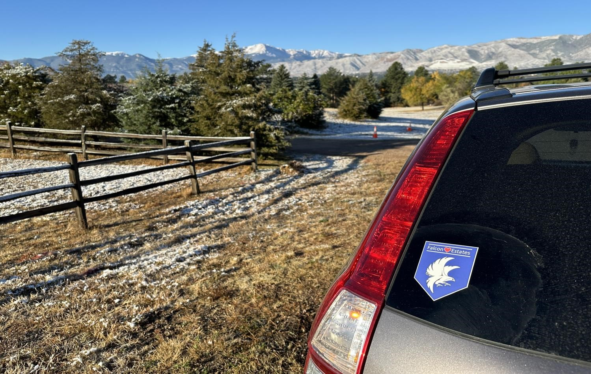

Falcon Estates Decal

Neighborhood News

FEHOA Board Meeting: November 19, 2024 @ 6:00 pm @ 21C Library Room B6

# Neighborhood Upcoming Events

Christmas Lights Contest – December 14 & 15, 2024

FEHOA Board Meeting Tuesday January 21 at 6:00 pm @ 21C Library Room B6 General Meeting Wednesday January 29, 2025

Neighborhood Dues

HOA Dues are due in January of each year. HOA dues: 2024 are $40. 2025 are $45

# Neighborhood Safety Awareness

THEFTS: Mailbox thefts continue. If you see something, report to CSPD nonemergency number (719.444.7200). Try not to leave letters and packages in your mailbox or at your door for any length of time. A locking mailbox is suggested.

HOMELESS: There is no "Hotline" for homeless reporting anymore (Use the GoCOS link – See Below). Please stay vigilant and review your property & vehicles often to secure it as much as possible. Note that the phone number to report such things is now 719-444-7000.

WILDLIFE: Please remain aware of our local wildlife as they can appear at almost any time. Please be SAFE and BE AWARE for yourselves, children, and pets! You are responsible for dead animals on your property. A large animal removal is expensive. Ensure dead animals remain on city property and call (719.444.7891).

NEIGHBORHOOD WATCH: If you are interested in volunteering to assist or being a watch captain for East or West please contact the board. Crime Prevention Officer (Brian Corrado) came to our July General meeting. Thanks Dawn Neeley, Mark Hostetter and Michael Sanchez.

# Neighborhood Cleanliness

Lawn Care: Ground cover, grasses and weeds, should not exceed 9 inches. You are responsible for easements and ditches on or adjacent to your property. Each property owner is responsible for cleaning and maintaining the culvert under their driveways to allow water to flow freely. Per the [City Code:](https://coloradosprings.gov/city-code-what-you-need-know)

PETS: Dogs must be on a leash, if not on your property. Thank you to everyone who cleans up after your dog.

Colorado Springs Regulations

[8.7: DOGS; DOMESTIC ANIMALS:](https://coloradosprings.gov/planning/page/dab-401-city-regulations-animals):

[6.7.107: DUTY TO RESTRAIN ANIMALS](https://codelibrary.amlegal.com/codes/coloradospringsco/latest/coloradosprings_co/0-0-0-7038)

1. It shall be unlawful for an owner or keeper to allow any dog, cat or hoofed animal to trespass on another's property or to run at large.

# HOAFE Free Libraries

Falcon Estates has free libraries at 7231 Milner on the West side and 7100 Ross Drive on the East side. The Ross library has been re-painted by Amanda.

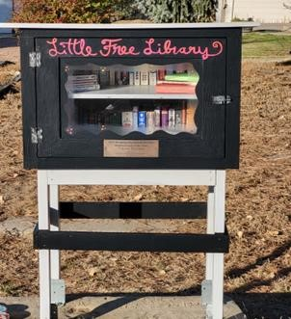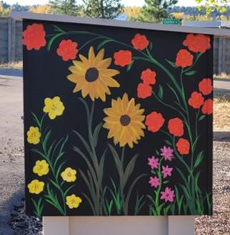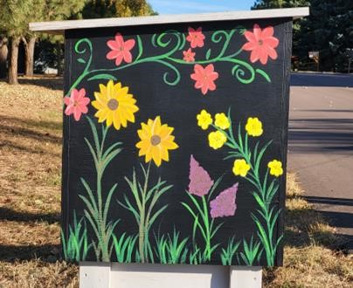

# FEHOA Board Meeting Summary (29 October 2024)

90 members of Falcon Estates have paid their voluntary dues for 2024, to date.

Neighborhood watch volunteers: Dawn Neeley, Mark Hostetter and Michael Sanchez. If you are interested in volunteering to assist or being a watch captain for East or West please contact the board.

Thank you to the Conners and Frasers for allowing the dumpster locations. Our first Community Party was successful with plenty of food, a bounce house and crafts for the kids. Thanks for attending and thanks to the Conners for hosting.

Board meetings for 2025 will be moved to the third Tuesday of each month to align with the financial report and allow time to update a newsletter.

The Christmas Lighting Contest judging will be December 14 & 15. This year we will judge a first and second place for the East AND the West. The categories from last year were too difficult to select and differentiate.

Falcon Estates decals have been created; see the first page of the newsletter. The first 200 have been donated to the HOA by a Falcon Estates community member and will be distributed to members with currently paid dues. We will budget for additional decals next year to distribute to any property owner in Falcon Estates HOA. Currently to get your decals (limit 2), a board member will try to deliver decals to your address, or you can pick decals from Stacie Conner 1341 Collins between 9 AM and 1 PM most days or pick up your decals at the January General meeting.

# Neighborhood Board & Volunteers

|  |  |  |  |
| --- | --- | --- | --- |
| DIRECTORS: |  | Phone | Email |
| Scott Conner | Chair | 954.668.7107 | JScott@ArcUrb.com |
| Andrew Dalby | Vice-Chair |  |  |
| Bonnie Bagley | Secretary | 719.593.0205 | Bon1Bon@comcast.net |
| Tim Fishel | Treasurer/Newsletter |  |  |
| Dana Olson | Board Member | 719.650.0216 | DanaOlson49@yahoo.com |
| Lynn Murphy    VOLUNTEERS:  Dawn Neeley  Stacie Conner | Board Member    ACC Chair  Events | 803.464.0831  954.665.7924 | Dawn.Neeley@mac.comConnerHome@hotmail.com |
| Mark Hostetter | Neighborhood Watch (East) |  |  |
| Michael Sanchez Neighborhood Watch | |

VOLUNTEERING

Members of the board would like any assistance you can provide. Let us know whatever you may be willing to help out to strengthen our community. Neighborhood animosity reduces property values and community cohesion. If you have a better way for the board to address issues, please let us know and join a board meeting.

## Contacting the HOA board

Members of the board would like to hear from all our neighbors. We ask that you reach out to us through the HOA email when you have formal HOA business. This helps us keep track of notices and helps us in our goal to be paperless.

Many of us have been friends and neighbors for years and have access to each other’s phone and email information, but we would like to keep those personal contact methods for our personal connections.

So, if you need to notify a board member about a neighborhood concern or need help, please use hoafalconestates@gmail.com

Neighborhood Conflicts

The HOA board of volunteers has developed a neighborly conflict protocol to clarify and outline the steps homeowners should take to help resolve neighborly disputes:

1. Contact the HOA in writing via email at hoafalconestates@gmail.com
2. The HOA will review the complaint and will do their best to determine if there are any violations.
3. If there is a violation and the complainant has not yet reached out to the neighbor, a board member can accompany you at your request.
4. Peaceful resolution is always the goal for both parties.
5. If the conflict is not resolved, both parties will receive a letter from the HOA addressing the issue.
6. If the conflict continues, the HOA will notify Colorado Springs code enforcement as applicable.

### Process for HOAFE Covenant and City Ordinance violations

* Review: Accept reports from residents and ACC. o Confirm: Two members of the board will confirm the reported violation.
* Response: Notification of the violation will be presented to the residence via a knock on the front door by two board members or via registered letter if access to the residence is restricted. o Report: If the violation cannot be resolved with the board, a violation will be reported to the city.

For areas of Falcon Estates owned by a business, violations will be reported to the city, if business management is unavailable or unknown.

## Neighborhood Media

FACEBOOK: Please use the search bar in Facebook and type in Falcon Estates HOA (official page) to find it. You will only need to enter your address and the administrators will admit you into the group. The board encourages you all to join for updates, information, and upcoming events.

## Neighborhood Links

FEHOA EMAIL: hoafalconestates@gmail.com

FEHOA USPS - HOAFE, PO Box 63183, Colorado Springs, Colorado 80962

FEHOA WEBSITE:<https://hoafalconestates.com/>

FEHOA By Laws: [HOAFE-Constitution-and-Bylaws-modified-19-Jan-2023-1.pdf](http://hoafe.com/hoa/wp-content/uploads/2023/01/HOAFE-Constitution-and-Bylaws-modified-19-Jan-2023-1.pdf) State of Colorado Laws:

<https://dre.colorado.gov/division-notifications/what-nuisance-and-what-can-you-do-about-them><https://www.shouselaw.com/co/defense/laws/harassment>

GoCOS (To report a city issue or contact a city department)

In your favorite search engine, type GoCOS and click the link

[(https://coloradosprings.gov/gocos)](https://coloradosprings.gov/gocos): The City of Colorado Springs has a new way to contact them to report a pothole, contact City Council, ask a question of city planners, report illegal camps or an abandoned vehicle, etc.

Colorado Springs Development Tracker (enhancing transparency) <https://coloradosprings.gov/developmenttracker>

## Pikes Peak Regional Emergency Preparedness and Safety Guide

The Pikes Peak Regional Office of Emergency Management (PPROEM) is responsible for providing mitigation, preparedness, response, recovery, and coordination for largescale emergencies and disasters, both natural and human-caused, to residents of El Paso County and Colorado Springs for the purpose of saving lives and preventing property damage. Available at pproem.com.

Notes from Columbine Estates (with permission)

No update

## Notice from Colorado Springs Land Use Division

Crest at Woodmen and Campus Drive (southeast corner) Zone Change to allow a 65’

maximum building height. Deadline for comments is November 12,

Logan.Hubble@coloradosprings.gov

## Scam Detection

* Check the domain name closely.
* Look for a padlock symbol.
* Use a website checker or safe browsing tools.
* Be wary of poor spelling, design issues, and other red flags.
* Check the domain age.
* Be cautious of deals that seem too good to be true.
* Look for user reviews and reports of scams.
* Double-check the sender's email address.
* Beware of messages with deadlines or threats.
* Avoid clicking on links in unexpected emails.
* Be skeptical of pressure tactics or urgent demands

Impacted area during a wildfire evacuation or other emergency situation.

West COS-1273 East COS-1283. <https://coloradosprings.gov/ready>

Colorado Springs Events

Peak Alerts:

Sign up to notify you of emergency situations that are a threat to life or property and

are deemed dangerous by public safety officials. Sign-up for push alerts at Peakalerts.org

Conservation and Environment Center (2855 Mesa Road)

Open House May - September on the first Saturday of each month 8 AM – 12 PM

Water Wise Plants Waterwiseplants.org

## New Residents to Falcon Estates

We need our existing residents help to notify us when a new resident moves into the neighborhood. Please, if you have a new neighbor, let us know so we can deliver them a “Welcome to Falcon Estates” basket. The basket will include gifts and information on the covenants and bylaws for Falcon Estates.

## Additions to Newsletter

Let us know if you have something to add to the newsletter or have suggestions for other articles.

## Neighborhood Smile (iQuote)

* If the only tool you have is a hammer, you tend to see every problem as a nail. - Abraham Maslow

* Despite the high cost of living, it remains popular. - Indian Hills Community Center

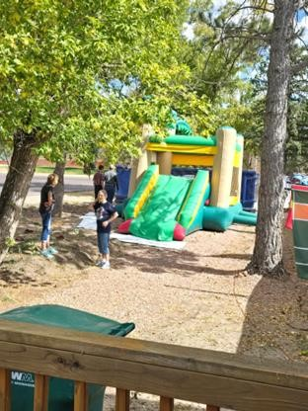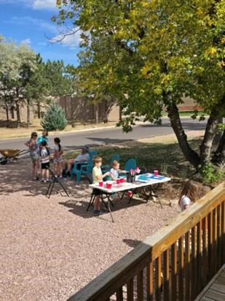

## HOAFE 2024 DUES FORM

If you are new to Falcon Estates or are a homeowner but not currently a member and would like to join HOAFE, please fill out the form below and return it with your dues to; HOAFE, PO Box 63183, Colorado Springs, Colorado 80962. Dues are $45.00 annually, please check out to ‘HOAFE’.

HOAFE 2025 Annual Dues - $45 PLEASE PRINT CONTACT INFORMATION

Name: Email:

Cell Phone: Second Phone:

Falcon Estates Property Address:

Mailing Address (if different):

********** HOAFE Treasurer Use Only *************************

2025 Dues Paid Amt: $45.00 Cash: ___ Check #: __________ Rec’d On: ____________

********** HOAFE Treasurer Use Only *************************